Top of Form

**Odin Automation APS 2.0 Addon**

**What is the Spam Experts APS 2.0 addon?**

The application integrates Spam Experts' advanced email protection system with Odin Automation, offering flexible and automatic protection of domain and email resources as well as a one-click login option to our dedicated SpamExperts control panel for managing specific settings, viewing detailed statistics and enhanced user control.

APS2.0 addon was tested and confirmed working with CB Commerce 20.4 and 20.5.

**Differences between APS 1.2 & APS 2.0**

* The major difference is that, in APS 2.0 you can make one resource per domain, rather than include a list of domains in one resource. This has many advantages, for example there can be a separate entry point per domain, each domain can have specific features turned on by default, etc.
* Installation steps have been modified: when importing the package, it's now required to Install an Instance and afterwards create the Resource Type.
* The User Interface view has been changed for the Application interface in POA Control Panel.

**Features**

* Allows the provider to manage the available/enabled products for a domain (Incoming, Outgoing, Archiving).
* Automatically adds or removes domains to and from the Hosted/Local Cloud.
* Configures the email address for the user.
* Allows the user to login to the control panel without having to enter a username/password.
* Allows the provider to "upsell" access to the control panel, but still apply protection to the domain.
* Creates one resource per domain, rather than include a list of domains in one resource.

**System Requirements**

To set up the endpoint for the application, you need to make sure your system meets the minimum requirements by having the following installed:

* Apache 2.0
* PHP 5.4
* ('date.timezone' must be set in php.ini)
* aps-php-runtime 2.1

**Provider Deployment Guide**

Deployment steps in order of succession:

**Application Endpoint**

The recommended way to deploy the application endpoint, is to use the [install script](https://doc.apsstandard.org/login/?page=/7.4/_downloads/endpoint.sh) provided by Odin:

The APS package can be found [here](https://documentation.n-able.com/spamexperts/userguide/Content/SpamExperts-2.0-20.app.zip).

1. Copy the APS package to the endpoint host (using 'scp' or a method of your choice):
   * ex: scp SpamExperts-2.0-19.app.zip root@endpoint.example.com: (the colon at the end is necessary, please do not leave it out)
2. You can '**wget**' the **endpoint.sh** script from the address provided above by issuing the following command in the endpoint host terminal:
   * ex: endpoint.sh spamexperts SpamExperts-2.0-19.app.zip
   * It will print the endpoint URL (e.g.: https://*endpoint_host*/spamexperts). Keep this URL on hand.
3. Restart the '**Apache**' service with:
   * service httpd restart, service apache2 restart, or the equivalent on your system

You can also check the official [APS Documentation](https://docs.cloudblue.com/login/?page=oa/8.0/sdk/pa/deployment/) for more details on deployment.

**APS Package Import**

Navigate to **Applications** > **APS Connectors**, as the provider and click the **Import Package** button as shown below:

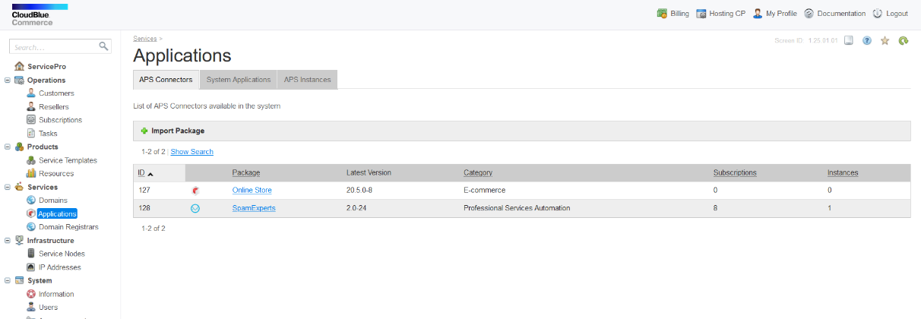

Select the local file option and search for the package to upload in your file browser. Once selected, submit the form:

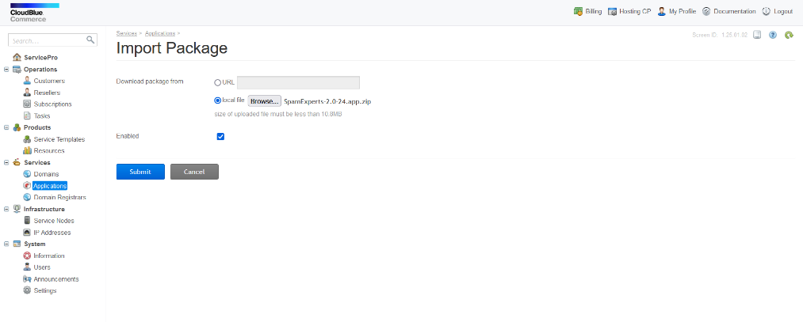

The APS package should now be available and will be validated in a few seconds

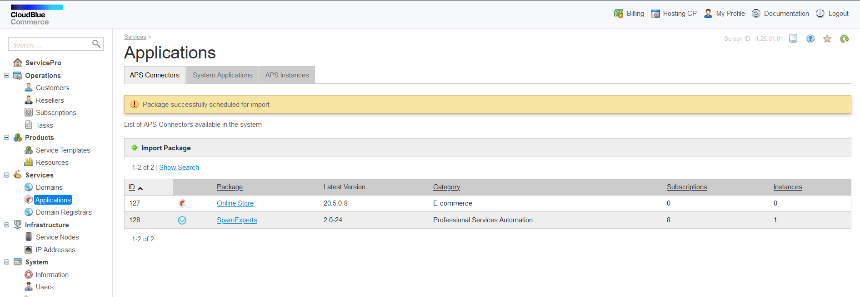

**Application Instance**

Click on the package name highlighted in blue, to enter the **Application**. This will redirect you to the following screen:

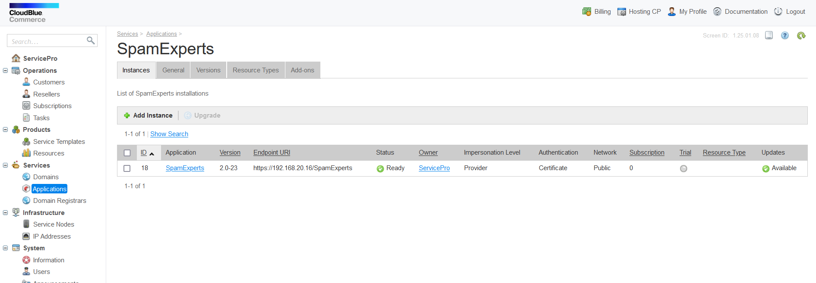

Go to Instances tab and click Add Instance:

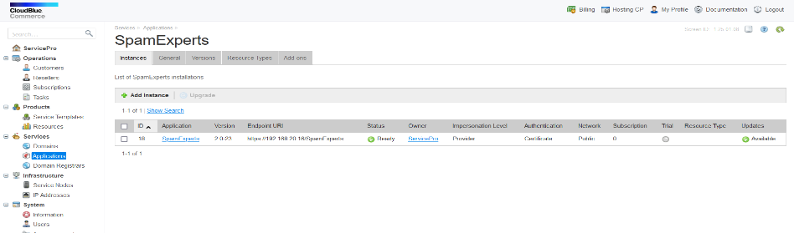

In the field for **Application API end-point URI**, type the URI of the endpoint configured in the previous section. Make sure that application instance version is the last version from package that is just imported in previous step. Other settings you can set like on the picture below:

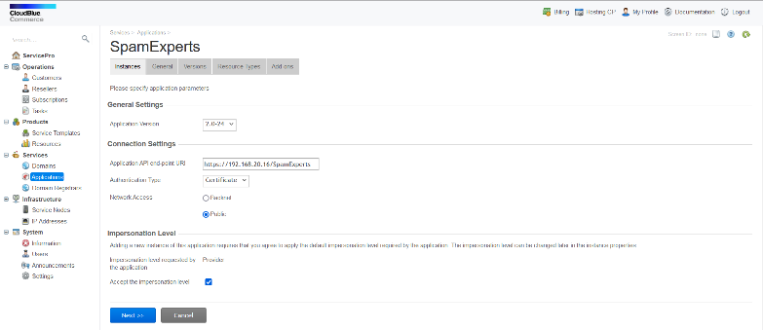

Click **Next**. This action will redirect you to the settings configuration screen below. Once there, fill in the information for your Spam Experts account. Note that you should specify the username and password of a Control Panel "Administrator" account and ensure the given user is allowed to create sub-admins.

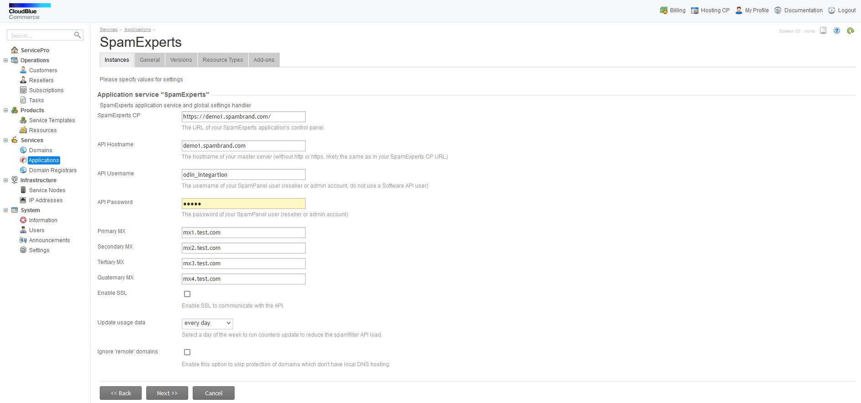

Click **Next** and verify the information on the following screen:

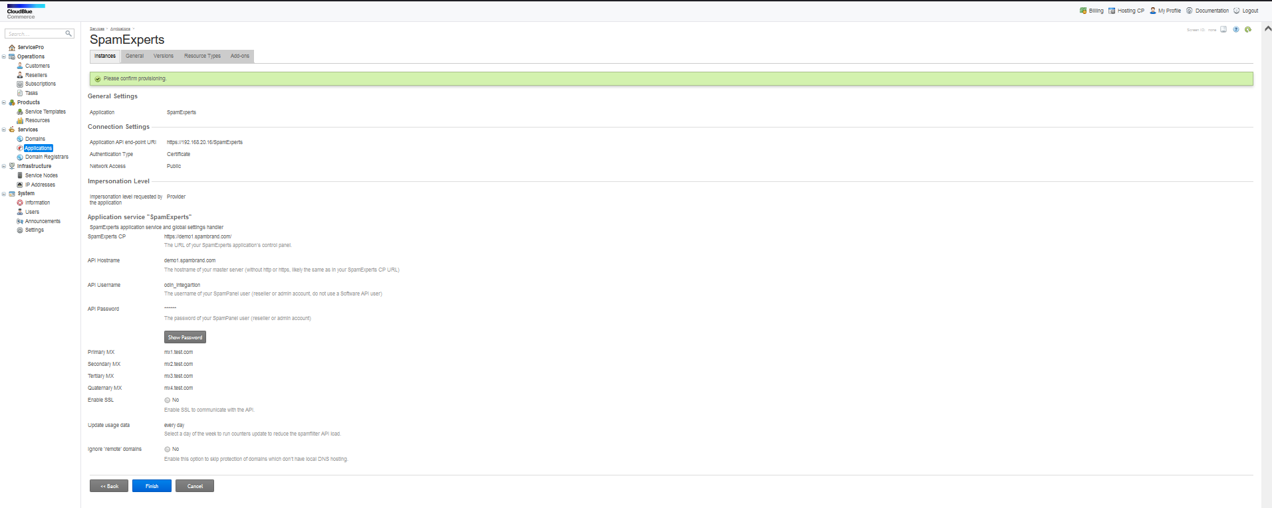

Click **Finish** and the instance will be ready for provisioning:

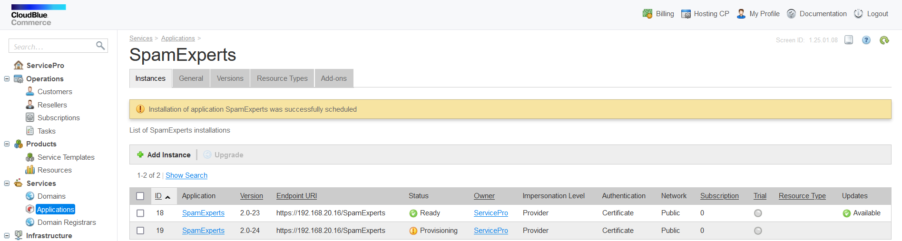

Wait for a few a moments for system to finish provisioning and then click on the application name and verify that the instance **Status is Ready** (Green):

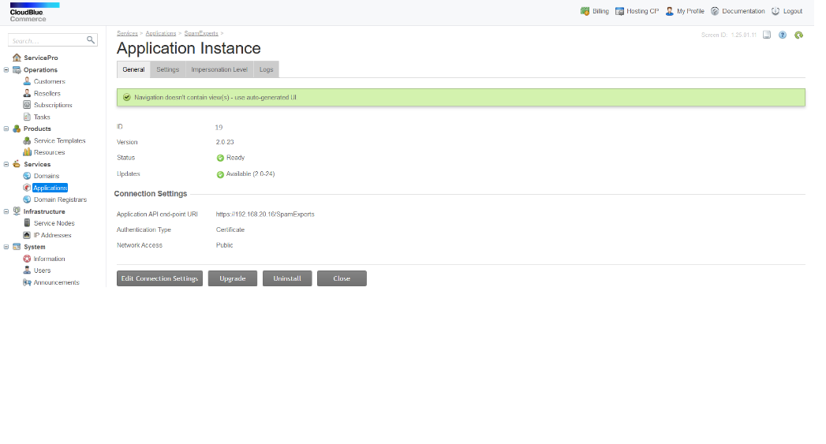

That means that instance is created. If the status is not green, it's most likely because of an issue with the endpoint. Try reinstalling the endpoint and pay close attention to the steps, also remove the existing endpoint directory first.

**Resources**

The application requires one Application Service Reference resource, for the application instance you've just created, and an **Application Service** resource for each of the following: **Context**, **Domain** and **Email**. The Context will be the only automatically provisioned resource. Application counters are optional, they allow more control over the application, users and resource administration/billing. For example, setting Domain and/or Email resources to a certain limit (either in Service Template or as a Resource Rate on Service Plan) will limit the number of domains and/or e-mail users that can be protected.

These are the minimal requirements you need to satisfy:

| **#** | **Name** | **Service Name** | **Default Limit** | **Auto-provisioned** |
| --- | --- | --- | --- | --- |
| 1 | Application Service Reference | N/A | 1 | N/A |
| 2 | Application Service | Context | 1 | Yes |
| 3 | Application Service | Domain | Unlimited | No |
| 4 | Application Service | Email | Unlimited | No |

Please follow these Initial Steps in order to create each resource:

In the application page, select **Resource Types** and click **Create**:

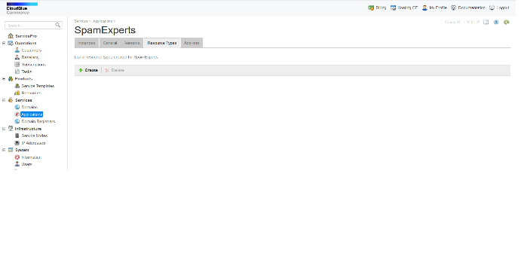

Select one of the following (please respect the order): Application Service, Application service Reference, Application Counter (KB), Application Counter Unit

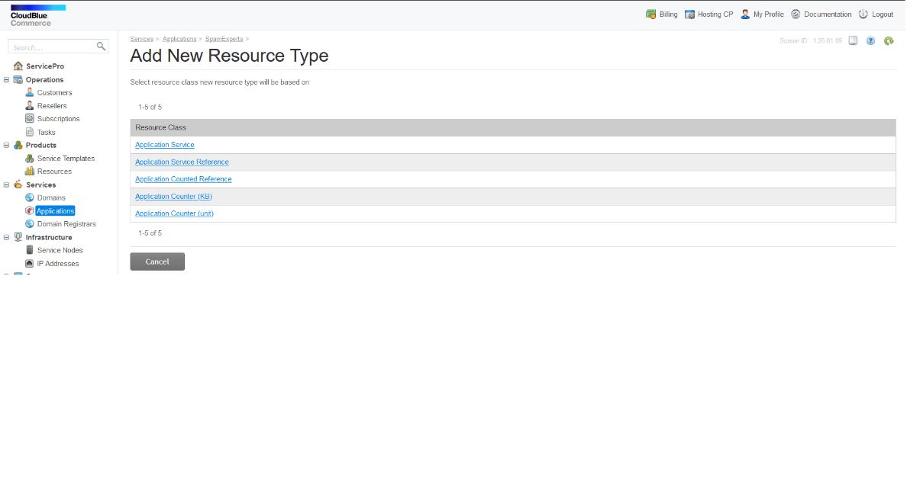

**We’ll start by selecting the Application Service Reference Resource Type**

Enter a name, in the screen below (ex: SE Application) and click **Next**

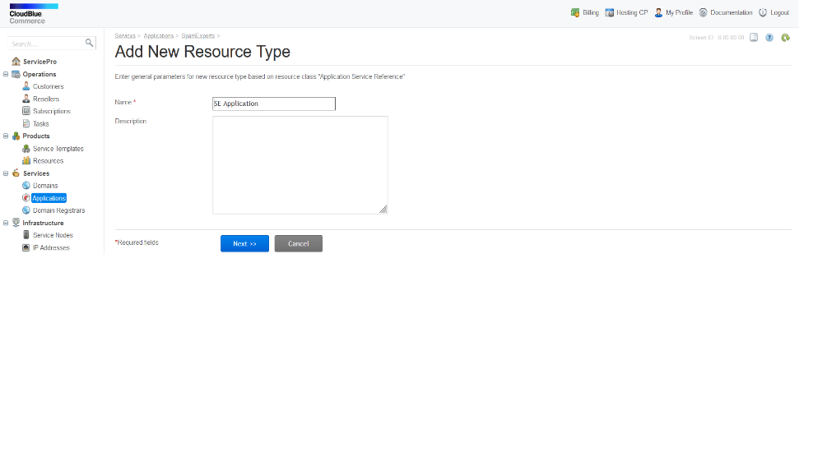

Select the **APS Type**, ex: Spam Experts:

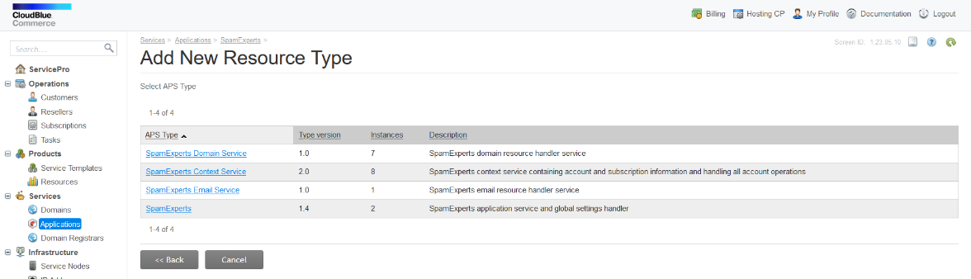

Then select the **Application Instance** created earlier:

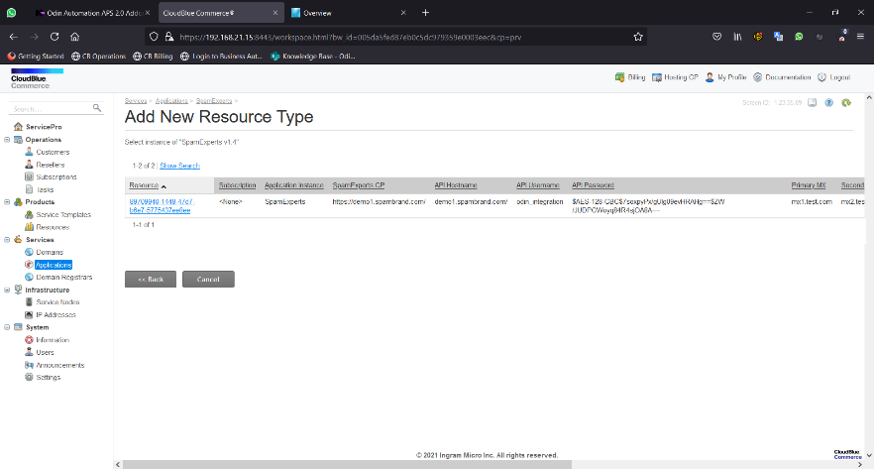

Click **Finish** once you see the text highlighted in green, in the screen below:

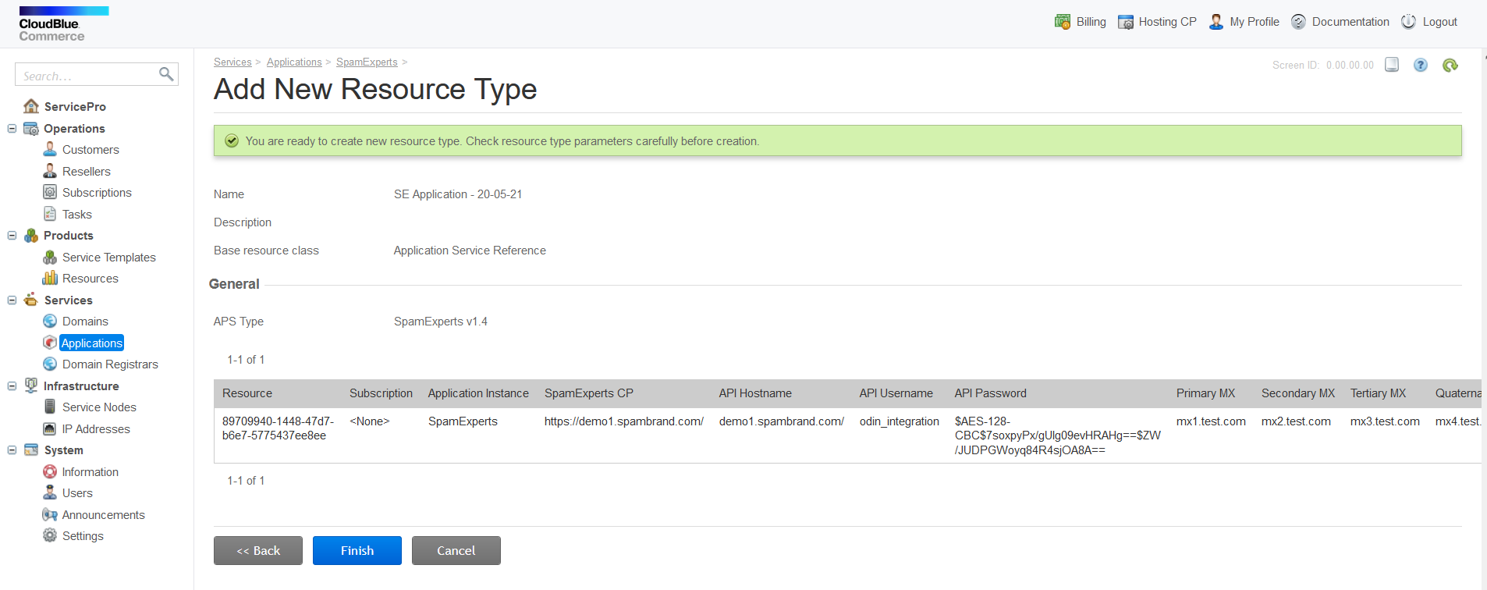

**Now to the second Resource Type: Application Service**

Go back to the application screen and select **Application Service**. You’ll be redirected to the screen below once more. Do this for each of the following names in turn, ex: SE Context, SE Domain, SE Email, and click **Next**

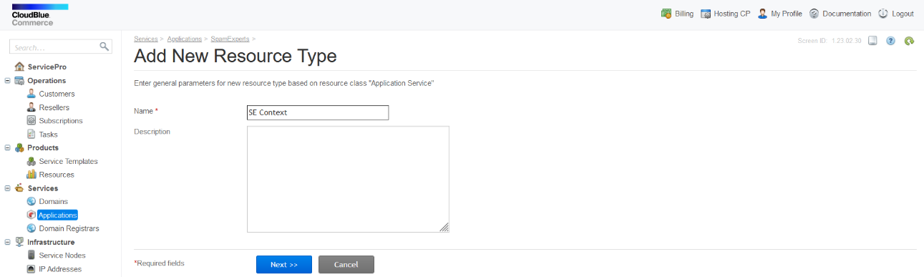

Select a resource handler for the service you chose (Context, Domain, and Email):

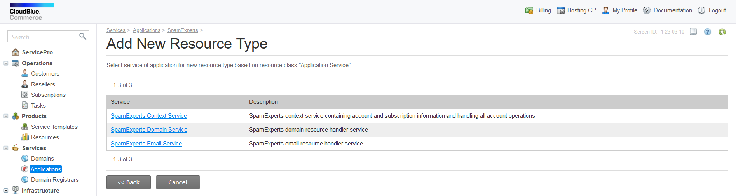

Once selected click **Next**

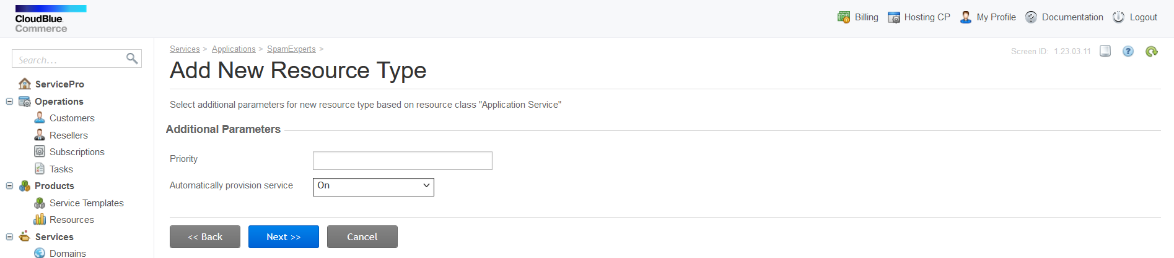

Click **Finish** once you see the text highlighted in green, and you’ve verified all the details are correct:

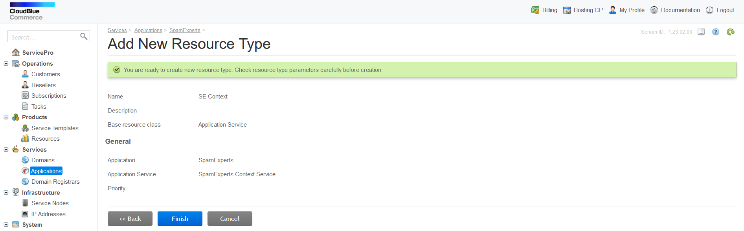

**For the last step, go back to the application screen and select Application Counter**

Enter a name for the counter and click **Next** (ex: Incoming):

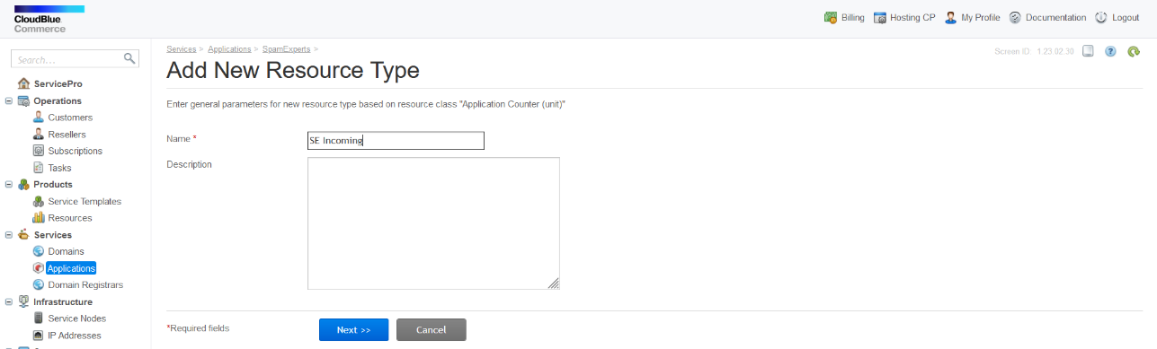

Select the respective counter from the list:

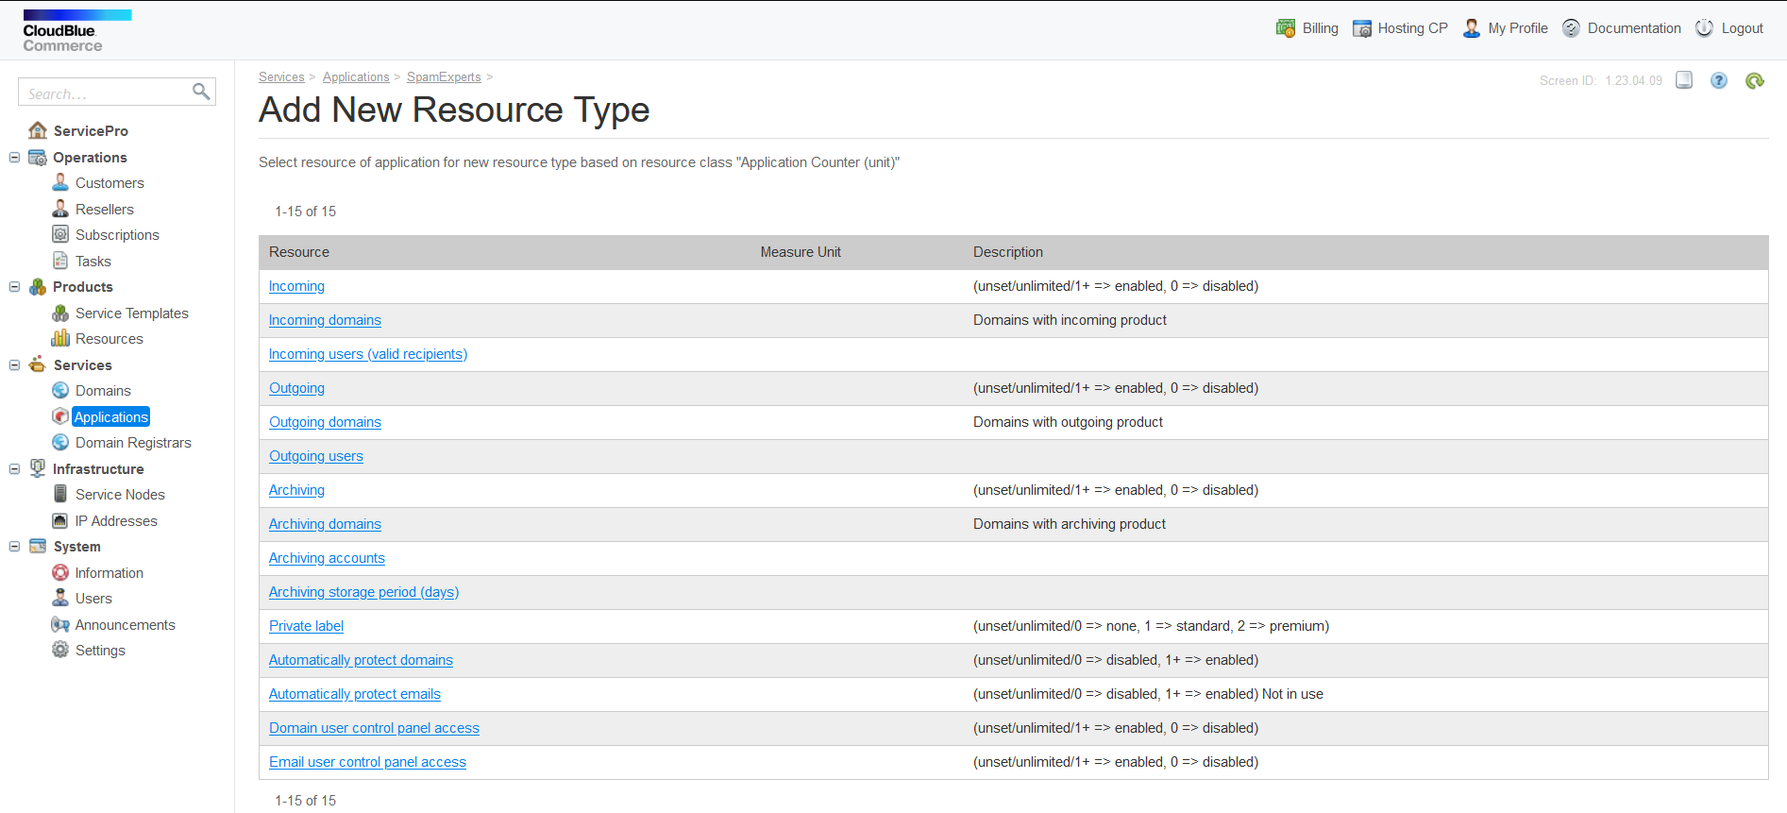

And click **Finish**, once you see the text highlighted in green:

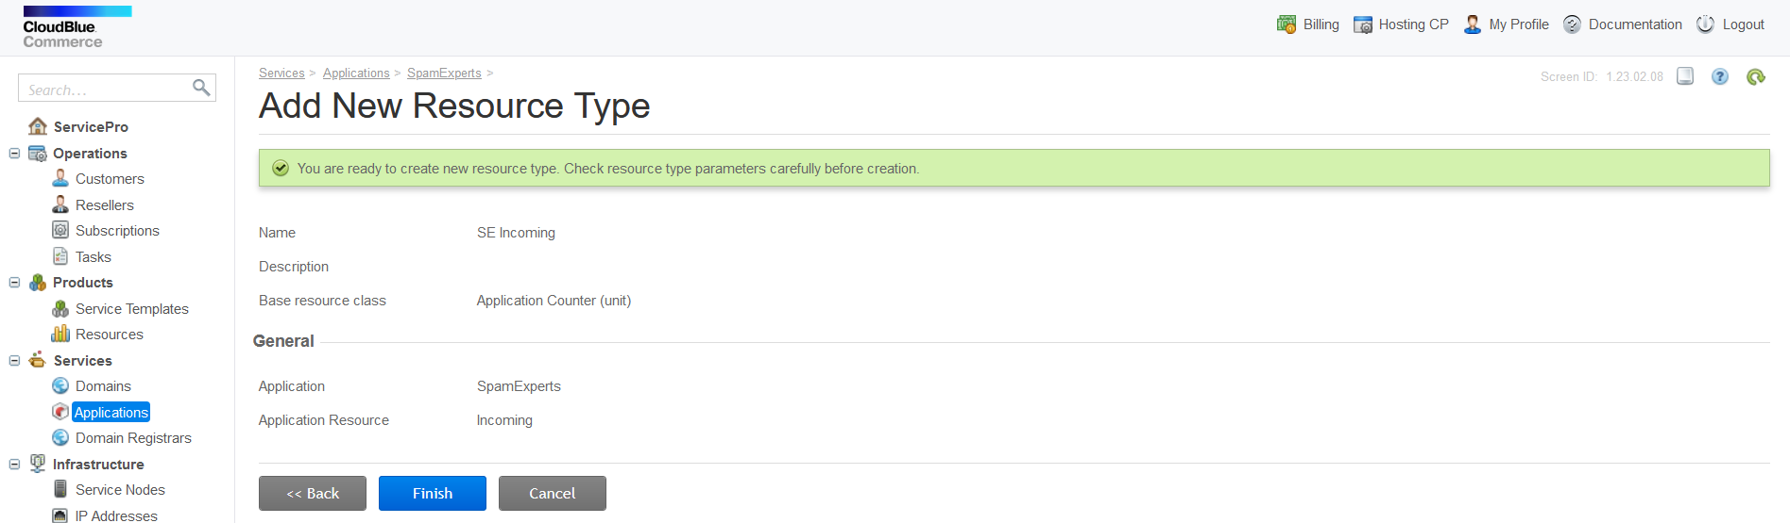

**Product type counters**

As seen in the image before the last, these are following counters that can be used in the package: Incoming, Outgoing, Archiving and their respective copies: Incoming domains, Outgoing domains and Archiving domains (can be used to the same effect, as currently the copies have identical functionality).

Setting these to 0 will disable corresponding product type for all domains protected by that Service Plan and setting them to 1 will enable it. This effectively defines what type of products will be enabled for protected domains.

**Resource Protection**

Already existing resources can be protected with **Total Protection** in the **Operations** menu, from the sidebar in the Customer Control Panel, or by selecting and protecting them in the domain/email lists.

**Control Panel Access**

By default, customers can click the **Login button** for a **Protected resource**, and be logged into the respective domain/email user account directly in the SpamExperts Control Panel.

**Other counters**

Counters that are not explained here are placeholders for future functionality. They will be documented when fully implemented.

**Service Template**

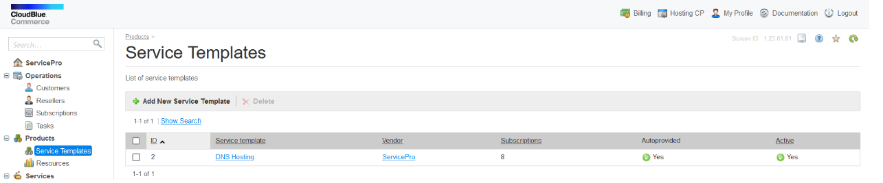

To access the **Service Templates** first open the **Products menu** in the sidebar and select **Service Templates**, then click the button **Add New Service Template** at the top of the screen, as shown above.

Next, specify the general parameters of the **Service Template**:

* **Name** - The name of the Service Template (ex: SpamExperts)
* **Description** - The description of the Service Template (optional)
* **Auto-provisioning** - Make sure it's selected
* **Account-Wide Services** - Make sure it's selected (POA 6.0)
* **Type** - 'Custom' should be selected

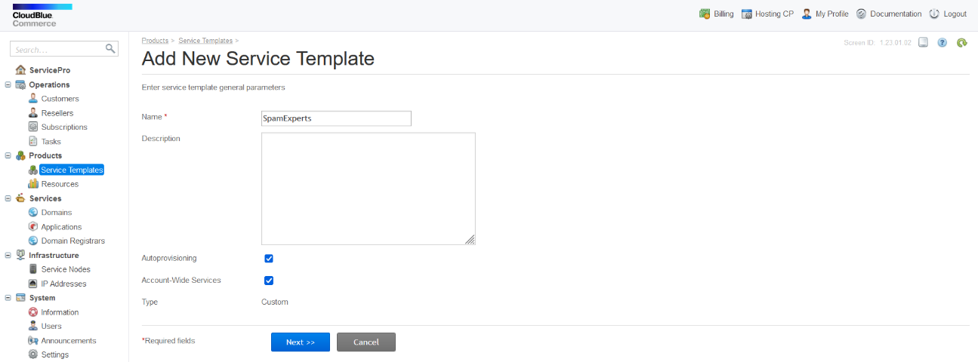

Click **Next** to proceed to the list of **Resources Types**.

Type for example: 'SE*' in the search bar to get the resources you've created:

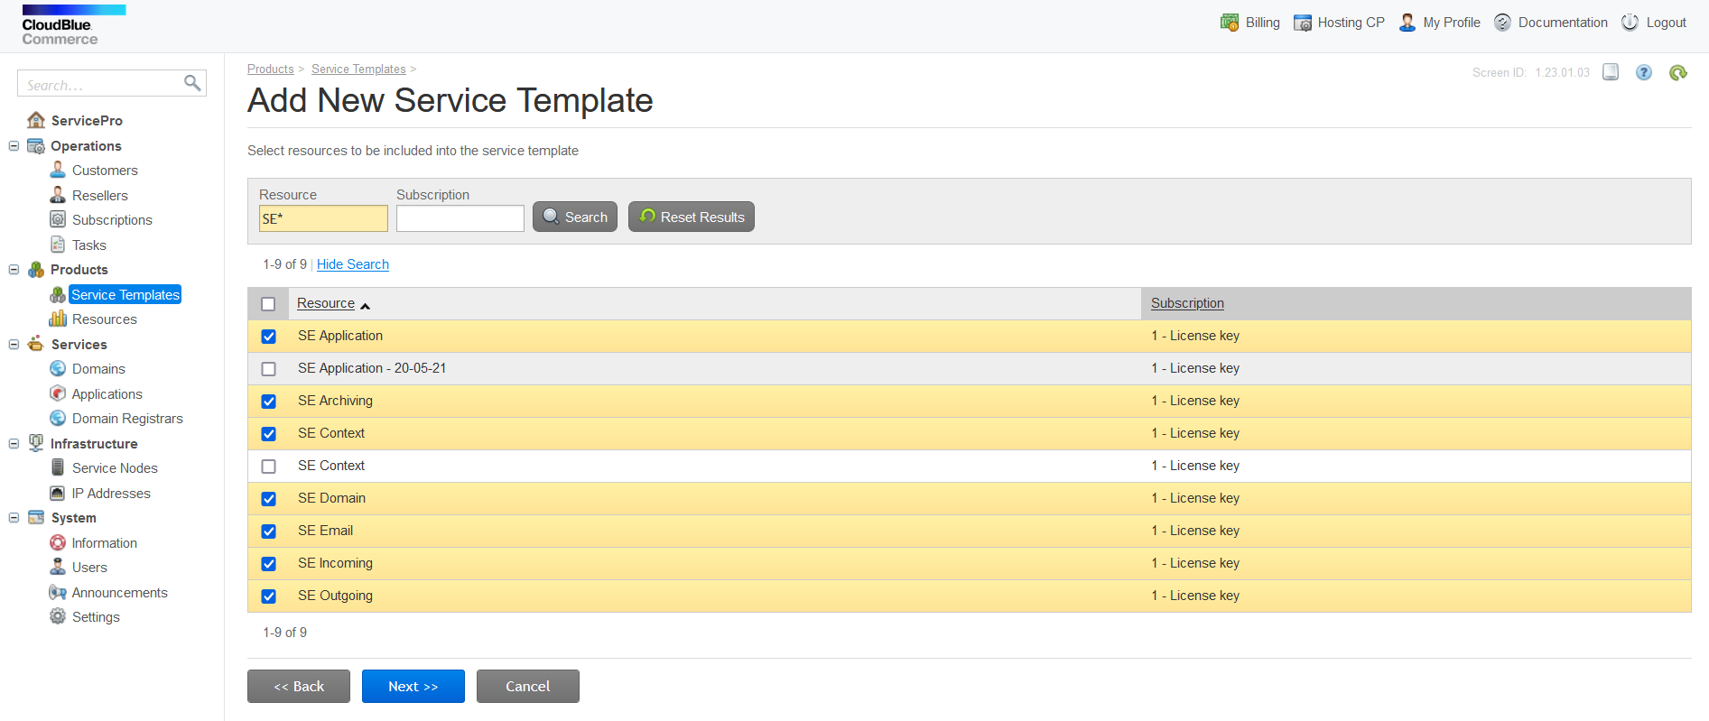

Select the SE resources you've created and click **Next**.

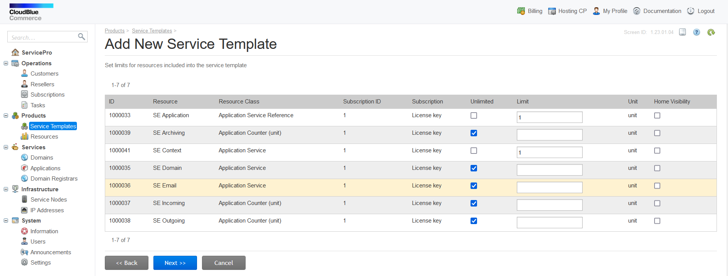

Specify the default template limits and click **Next** as shown above.

The Application Service Reference (SE Service) and the Context Service (SE Context) limits must be set to 1, the rest can be Unlimited by default or customised as required.

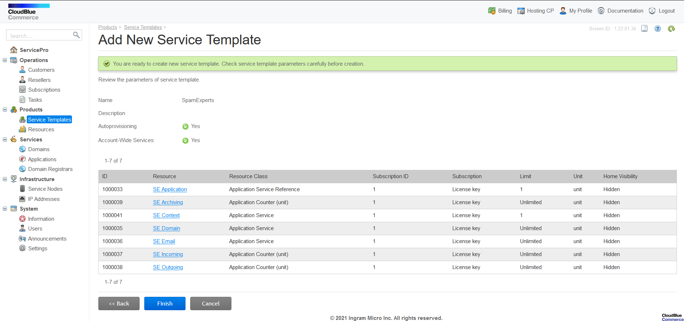

Review the resources and limits on the final page and click **Finish**.

**Service Plan**

If you wish to create a service plan, please follow these steps:

1. Go to the **Billing panel**, open **Products** and choose **Service Plans**
2. Click on the button labelled **Add New Service Plan**
3. Select the **Generic Service Plan** option
4. Type a service plan name into the **Name field**. This is the name the customer will see in the shop so use a good one.
5. To select the **Service Template** click on the right icon, and search for the service template defined before, by name. The **Service Template** determines resources that are provided to the subscriber of the service plan.
6. Type both short and long descriptions of the service plan into the **Description** and **Extended Description** fields respectively. Both descriptions are shown to customer in the online store. Both descriptions can be input in HTML format.
7. To define the **Plan Category** field, select a category which your new service plan will belong to. The plan category defines how the plan will be taxed.
8. Select a service term from the **Service Terms** list.

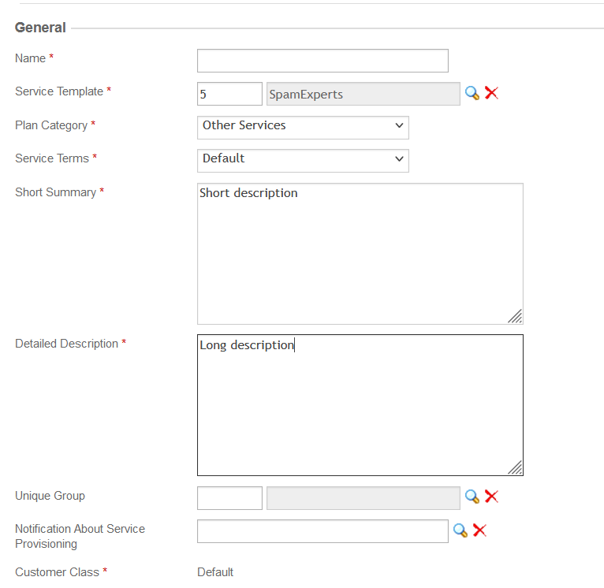

1. Check the **Published** checkbox, to make the service plan available for sale.
2. The **Service Plan** can also be included in a unique group. Unique groups restrict the combination of service plans in a single subscription: service plans belonging to the same group cannot be up-sales of each other
3. **Billing Period Type** list. The **Billing Period** field differs depending on the billing period type. The following types are available:
   * Fixed Number of Months - billing period in months
   * Fixed Number of Years - billing period in years

Here can be set many other parameters related to billing (Billing model and period, Recurring Prices, Autorenewal of subscription…) as shown on the image below:

1. Click **Next**
2. Set Subscription periods and Fees

1. Click **Next** and go to screen where you can update Subscription Periods. If you know that you setup everything correctly you can click **Finish** on this screen or you can click on **Setup Plan Rates** to update fees. And then click **Finish** and Service Plan will be created.

**Subscription**

To make a Subscription, navigate to the **Billing** menu, choose **Subscriptions** and click the **Add New Order** button:

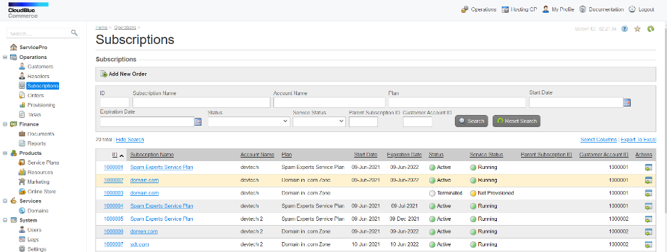

Select the account you wish to subscribe, choose Service Plan you want to purchase and Subscription period previously made and optionally fill other fields from picture and click **Next**:

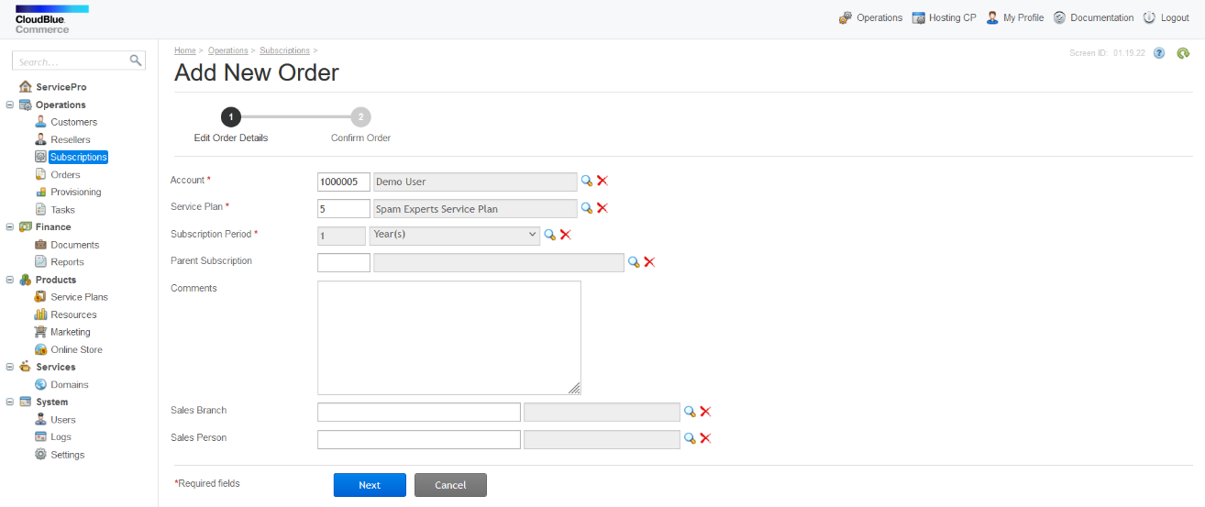

Optionally enter Domain name:

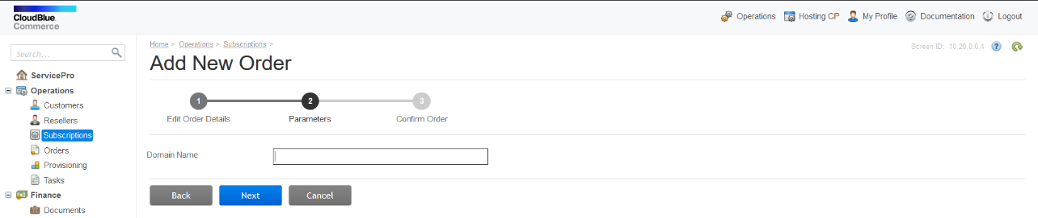

Click **Next**:

Here there is on overview of previous steps:

Review and click **Place Order**.

Navigate to Operations panel and click on **Tasks** and check that all the tasks related to the Spam Experts subscription are completed successfully.

To protect all the customer's domains and emails, navigate to the **Customer Control Panel**, Login as Customer, click on “**Spam Experts**”, click on the **Operations** side menu, and click **Protect All**.

If an error occurs, cancel the failed tasks in the Tasks area and ONLY afterwards unsubscribe the customer.

We also advise that you click the failed task and take a screenshot or two, of the displayed information, in case this happens again and you are sure the instance information is correct. You can try again if you've solved the issue, otherwise please [contact support](mailto:support@spamexperts.com) .

**Unsubscribing**

To unsubscribe, navigate to the **Customer Control Panel**, Login as Customer, select “**Spam Experts**”, go to the **Operations** menu and click **Uninstall**. Only after you have done this, navigate to Subscriptions in the Provider Control Panel, select the subscription and click Unsubscribe.

If you choose not to Uninstall first, the MX Records added to domains by the application will remain attached and cannot be removed manually. They can be disabled, but if you forget to do this and you want them removed, you have to re-subscribe the customer and hit Uninstall.

**Subscriber Guide**

We have taken care to expose our protection system in the simplest way possible to the end user and with the least amount of manual intervention.

After subscribing, the only priority a customer has, is to ensure resources (domain and email) are **Protected**. This is done very easily with just one action for multiple items and can be automated for domains by the provider. More details below.

**Domains & Emails**

In the Spam Experts tab, from the **Customer Control Panel**, you will find a list of your domain and service user (email) resources. You can perform a number of actions on one or more of these resources as described below.

List of Domains:

List of Emails:

**Resource Actions**

**Check**

**Check a resource's protection status**. The status will be updated in its respective column.

**Protect**

Protect a resource with SpamExperts. Resources will have special SpamExperts users created, the Login button will take you to the SpamExperts User Control Panel if that feature is enabled by the provider and domains will have their MX records changed.

If you want to protect unprotected report, click on the checkbox next to resource you want to protect and click **Protect**:

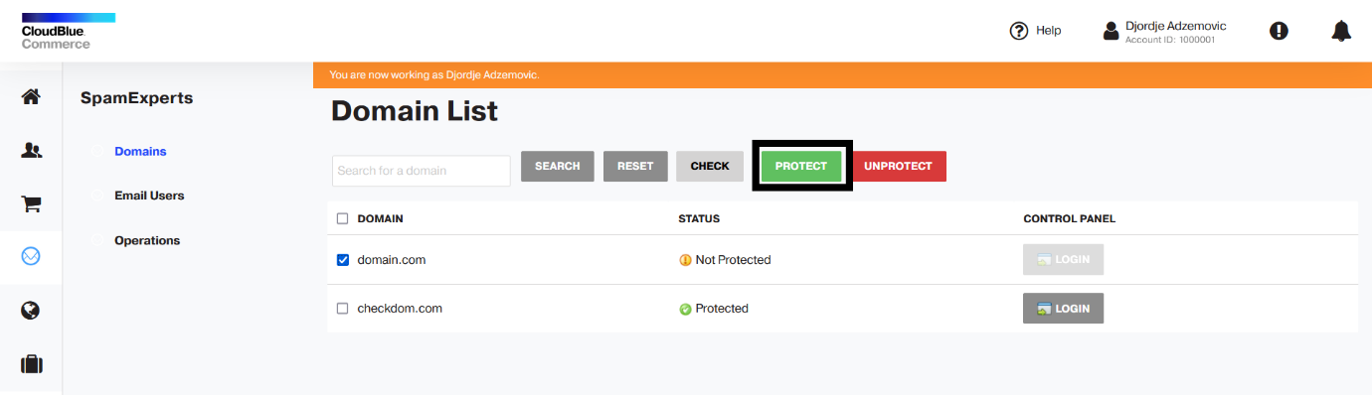

**Unprotect**

WARNING: Please use this action with caution. You will generally not need it in most cases, as the only reason to use it is when you are limited in the number of resources you can protect at a time, and want to swap protection between an old and a new resource. Otherwise, you will want your resources Protected at all times!

**Unprotect a resource**. Users will be removed from SpamExperts, domains will be removed if unprotected and MX records will be reverted.

To unprotect resource, click checkbox next to that resource and click **Unprotect**

**Misc actions**

These are: **Login**, which allows you to log in the SpamExperts web interface as the respective domain or email user, and the **Search functionality**, which you can use to find domains and emails.

**Operations**

The operations page contains several global operations that are described there. In short, you can: protect all your resources, remove protection from all your resources and refresh the SpamExperts container, which updates customer account information in our systems If for any reason there's a problem with it, re-creates the SpamExperts administrator account if not present.

**Service User**

Managing Service Users are also enabled in Customer Control Panel, under Users tab.

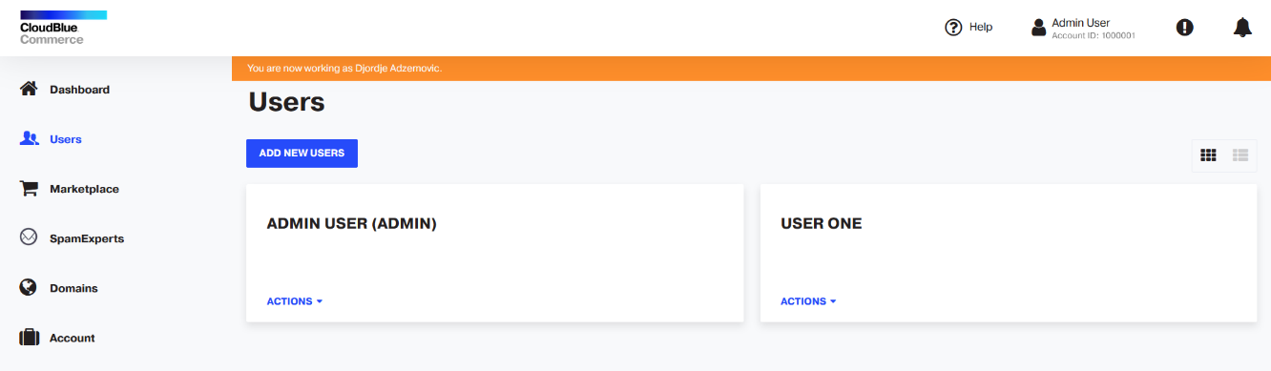

**Click on Add New Users** to add a user. Fill in First and Last name and Email. Also you can add Access Rights for that user, fill in different email for notifications for user. There is a way to add multiple users at once, just click on **One More Users** and fill in data of the next user. It is also enabled to decide whether or not services will be assigned to user and also if user will receive activation link before he/she can access.

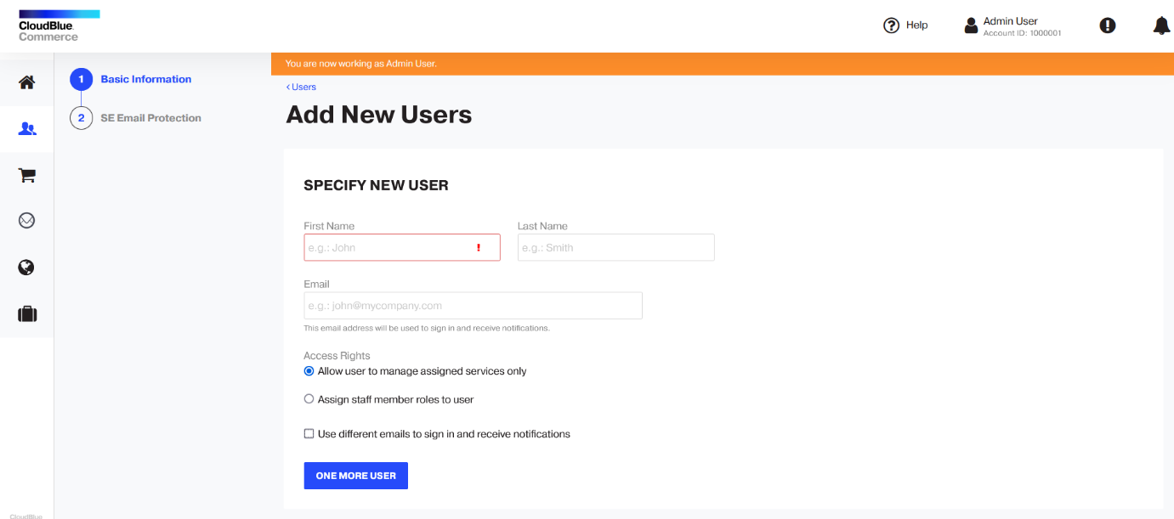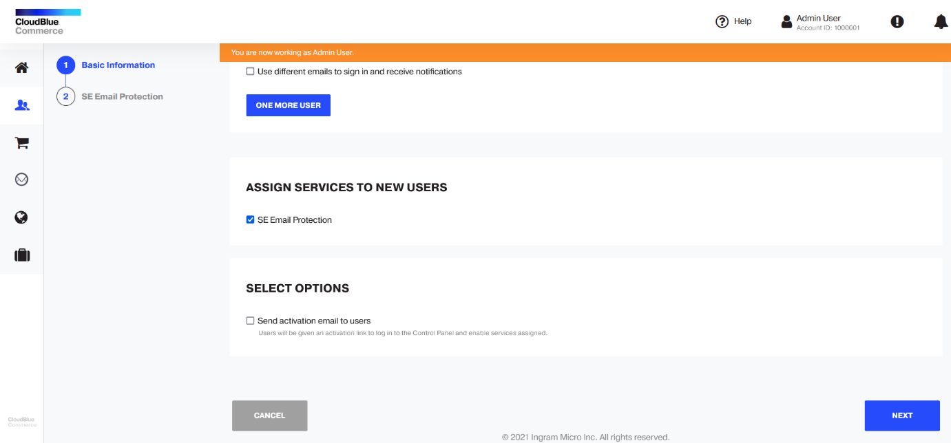

After click on **Next**, screen with info how to protect user appear.

Just click **Finish** and service user will be created

Under Actions and View Summary you can see details about User and will be able to edit details.

To see, Protect or Unprotect service users go to SpamExperts Email Users tab.

Service users protected with SpamExperts can log in to the SpamExperts Control Panel as email users by using the button available in their OA web interface:

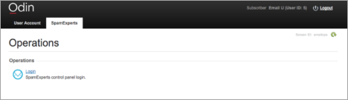

**Debugging and support**

When you encounter an issue, check the logs located in '*/var/www/html/spamexperts/logs*'. The application stores up to 30 days of logs, with detailed information about the application's activities and the reason(s) it failed in case of an error.

To enable the logging of more extensive information (API calls and results), open */var/www/html/spamexperts/Logger.php* and add a '#' where indicated. Run the steps to reproduce the issue after you've enabled advanced logging and turn it off afterwards.

Our support team is always happy to help you with any issue. Please save relevant logs when contacting [support](https://www.spamexperts.com/about/contact).

**Resource counters**

By default all counters update every hour. However, since there are many counter in the APS package, there is the possibility now to schedule the counter update for a certain day.

**Upgrading the Addon**

To upgrade the application to a new version:

1. **Import** the new version of the application in **Applications**
2. **Upgrade the endpoint scripts**. For this you can use the automatic installation script: *endpoint.sh --upgrade ENDPOINT_NAME SpamExperts-2.0-4.app.zip*
3. Replace the version number with the one you're upgrading to and restart apache afterwards, with "*(sudo) service httpd restart*", “*(sudo) service apache2 restart*", or its equivalent.
4. Go to the application in POA, SpamExperts > General and Upgrade the instance. You can also upgrade from the instance screen.
5. Perform steps 2-3 for each endpoint/instance you want to upgrade.

**Upgrade from APS 1.2**

Here are the steps of the upgrade path:

1. In the Provider Control Panel, go to Applications > **Spam Experts Integration** > **Resource Types**, and click the main **Application resource** (usually named 'SpamExperts', it contains the Global settings).
2. In the main **Application resource**, go to **Activation Parameters** > **Global** settings and click **Edit**.
3. Change the SpamExperts web interface URL and the API hostname to some other, non valid names and click Submit (ex: instead of my-spamexperts.com you could write my-spamexperts.nonvalidname.com).
4. Go to **Subscriptions** and **Unsubscribe** the subscriptions you want to upgrade, to use the new app.
5. Go to **Tasks** and verify all related tasks have finished successfully.
6. Subscribe customers to the new **SpamExperts 2.0** service template (installed by following our Knowledgebase guide).
7. Go to the **Customer Control Panel** > **SpamExperts** > **Operations** and click **Total Protection**. This will ensure existing domains and service users are synced and Protected between the new 2.0 subscription and the SpamExperts servers.

You can install the new APS 2.0 SpamExperts application either alongside the old one (keeping old service templates in case you need them) or after uninstalling the old service templates, resources and app. The choice is all yours.

To install the new app, you must follow the process described in the Provider Deployment Guide detailed above.

If an error does occur at any point, check in Tasks, go to the failed task (if any), click it and chose to cancel that task only (not the task tree). Do this for any failed task in succession. Don't cancel all the tasks, some may be important and will be triggered automatically, after you cancel the failed task.